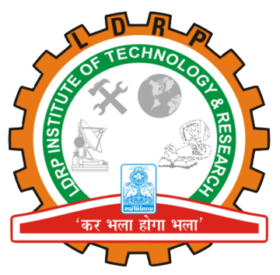
LDRP Institute of Technology and Research Bachelor of Engineering
Department of
Computer Engineering
Project Progress Report Card (Semester - 8)

Title of Project:- Superme (RTS Game)

Enrolment No.:- 1418BECE30012

Name of Student(s):- Anish Acharya

Internal Guide Name:- Prof. Krutika Vyas

Exam Date: / /20__
Comments of Internal Project Progress Review (Semester- )
Comments Given by Internal Examiners | Modification done based on Comments
Internal Examiners:  Name: Name:  Sign: Sign: | Internal Guide:  Name :  Sign:  Date:

Exam Date: / /20__
Comments of Internal Project Progress Review (Semester- )
Comments Given by Internal Examiners | Modification done based on Comments
Internal Examiners:  Name: Name:  Sign: Sign: | Internal Guide:  Name :  Sign:  Date:

